


Assignment 1 – SQL

Group 06 Members:
De La Cruz Rubianes Edith
Kumar, Akash

Sassi, Bruno

University of Niagara Falls Canada
Master of Data Analytics
SQL Databases
Winter 2025
Due date: Sunday February 2, 11:00 PM



Question 1 (5 marks)

This question evaluates students’ ability to:
LO1: Analyze the gathering requirements needed for conceptual database design.
LO2: Apply Entity-Relationship diagrams to model gathered requirements.
LO3: Apply Entity-Relationship diagrams to a collection of relations.

During interviews with librarians in a university, the following requirements of a database were collected. Several key requirements were identified to design a comprehensive database for managing library resources and patron interactions. Below are the refined and elaborated requirements:

Primary requirements:
- The library intends to manage information about its collection of books.
- Patrons can borrow multiple books.
- The database should track borrowing activities for these books.

Detailed requirements:

Book Characteristics:
- Each book has a unique identification number (ISBN), title, author(s), publication year, and category.
- Books can belong to only one category.
- The library needs to know the number of copies available for each book.
- Information about the publisher and edition should also be tracked.

Laptop Characteristics:

Attributes:
- Serial Number/Identification: A unique identifier assigned to each laptop within the library's inventory system.
- Availability Status: Indicates whether the laptop is available for borrowing, checked out by a patron, reserved, or unavailable (e.g., undergoing maintenance).
- Brand: indicates the brand of the laptop.

iPad Characteristics:

- Serial Number/Identification: A unique identifier assigned to each iPad within the library's inventory system.
- Availability Status: Indicates whether the iPad is available for borrowing, checked out by a patron, reserved, or unavailable.
- Model: Describes the specific model of the iPad.

Patron Characteristics:
  - Each patron has a unique identification number, name, contact information (e.g., email, phone), and membership status (e.g., regular, premium).
  - Patrons can borrow books and devices from the library.
  - The database should record the date when a patron borrows an item and the due date for returning it.

Category Characteristics:
- Each category is uniquely identified and has a name.
- Books can be classified into one or more categories.
- Information about the popularity or availability of items in each category may be tracked.

Using draw.io, design the entity relationship diagram representing the required database of this library system.

Instructions:
- Submit a pdf file showing the ER diagram by the due date of this assignment. The evaluation of this question will be based on the submitted pdf file.
- Share the link to the draw.io of this ER diagram to Sundus.Shanef@unfc.com as an editor. This is required to complete the evaluation of this question.

Solution 1:

File for draw.io diagram was uploaded to Cascade.

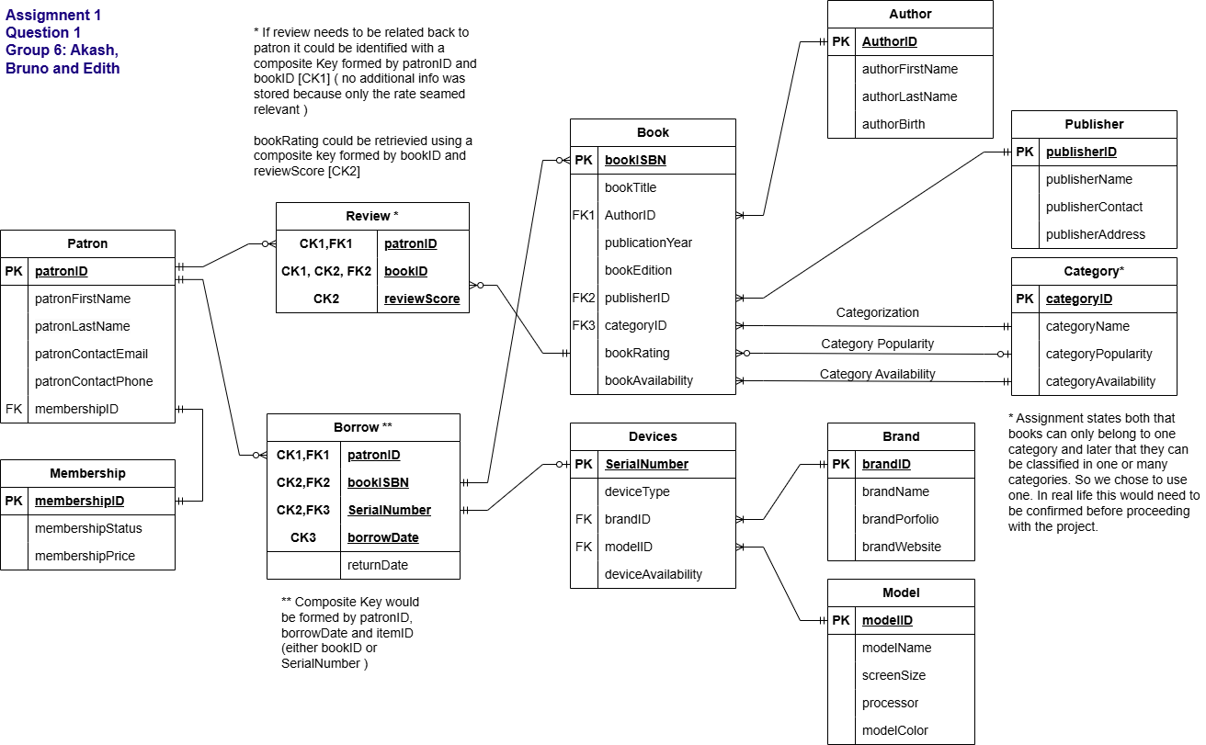

Question 2 (5 marks)

The question evaluates students’ ability to understand and code SQL queries specially the followings:

1. apply simple queries using the SELECT statement.

2. implement filtering with the WHERE statement.

3. employ arithmetic and string functions.

This question concerns the World database that is installed with MySQL.

- Write a query using MySQL to return all countries included in the World database.
- Write a query using MySQL that returns all countries in Europe.
- Write a query using MySQL to return all countries that speaks English as an official language with percentage greater than or equal to 70.
- Write a query using MySQL to return all countries that received their independence in the 18th century.
- Write a query using MySQL that returns the following dataset.

Name | CountryCode | District
Delhi | IND | Delhi
Ludhiana | IND | Punjab
Amritsar | IND | Punjab
Jalandhar (Jullundur) | IND | Punjab
New Delhi | IND | Delhi
Patiala | IND | Punjab
Bhatinda (Bathinda) | IND | Punjab
Pathankot | IND | Punjab
Hoshiarpur | IND | Punjab
Moga | IND | Punjab
Abohar | IND | Punjab
Delhi Cantonment | IND | Delhi
Instruction:
- Submit the SQL script (.sql) file of each of the above five queries by the due date of this assignment.
- To save a .sql file on your desk: in your MySQL, click on file menu then click on save script as.

Solution 2:
All files will be uploaded to cascade, however we decided to additionally write the code here to further illustrate our answer and provide a backup register of our work:
A)
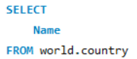

B)
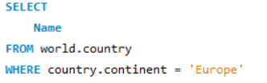

C)
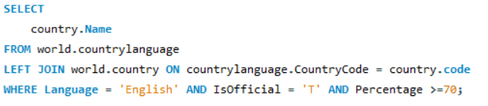

D)
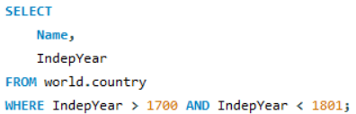

E)
